|  |  |
| --- | --- |
| KWAME NKRUMAHUNIVERSITY OF SCIENCE AND TECHNOLOGY.  BSC. MECHANICAL ENGINEERING  Date:25/02/2014 | GROUP MEMBERS  ADDAI TWITCHELL DOMPREH--9788613  AFOTEY ROBERT OTU--9789813  ASAFU-ADJAYE OHENEBA BOATENG--9792813  ENOS LESLIE--9796213  BASIC ELECTRONICS  LAB REPORT |

Characteristics Curve of a Semiconductor Diode

1. Objective of the experiment

The experiment demonstrates the forward and reverse behaviour of a diode.

1. Components and Instruments
2. Power supply d. Fixed resistor 56 Ω
3. Switch e. Diode
4. Variable resistor 1000 Ω f. Multi-range measuring instrument
5. Voltmeter h. Ammeter

FORWARD BIASED REVERSE BIASED

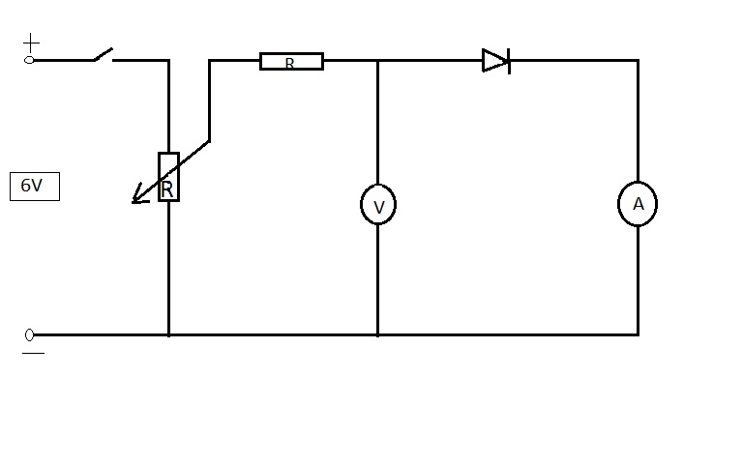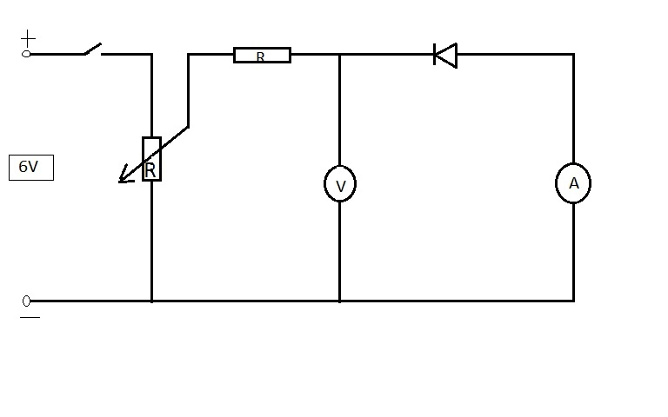BLOCK DIAGRAM

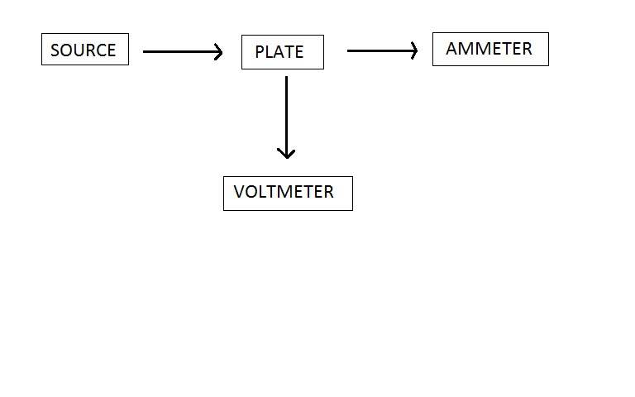

Table Of Values

Forward-Biased Reversed-Biased

|  |  |
| --- | --- |
| VF | IF /mA |
| 0.0 | 0.00 |
| 0.1 | 0.00 |
| O.2 | 0.00 |
| 0.3 | 0.00 |
| 0.4 | 0.00 |
| 0.5 | 0.00 |
| 0.6 | 0.02 |
| 0.7 | 0.14 |
| 0.8 | 0.55 |
| 0.9 | 1.15 |
| 1.0 | 5.40 |

|  |  |
| --- | --- |
| VR | IR/µA |
| 0.0 | 0.00 |
| -0.5 | 0.00 |
| -1.0 | 0.00 |
| -1.5 | -0.20 |
| -2.0 | -0.80 |
| -2.5 | -2.80 |
| -3.0 | -7.60 |
| -3.5 | -22.00 |
| -4.0 | -67.20 |
| -4.5 | -202.60 |
| -5.0 | -544.00 |
| -5.5 | -1134.00 |
| -6.0 | -1882.00 |

EVALUATION

1. In the forward direction the diode starts conducting current at 0.60V.
2. When the diode was reverse biased the resistance was very high and that allowed only small or no current to flow through the circuit. But as voltage continued to increase there was a sudden increase in current.
3. When VD = 0.7V,I = 0.14 mA

Ohm’s Law: R =V/I

R = 0.7/0.14×10-3

R = 5000.00 Ω

When VD = 0.9V,I = 1.15 mA

Ohm’s Law: R =V/I

R = 0.9/1.15*10-3

R = 782.61 Ω